Github: <https://github.com/sundershyam04/Phase-4-Nunit-SchoolOOPS-Practice-Project.git>

Nunit test:

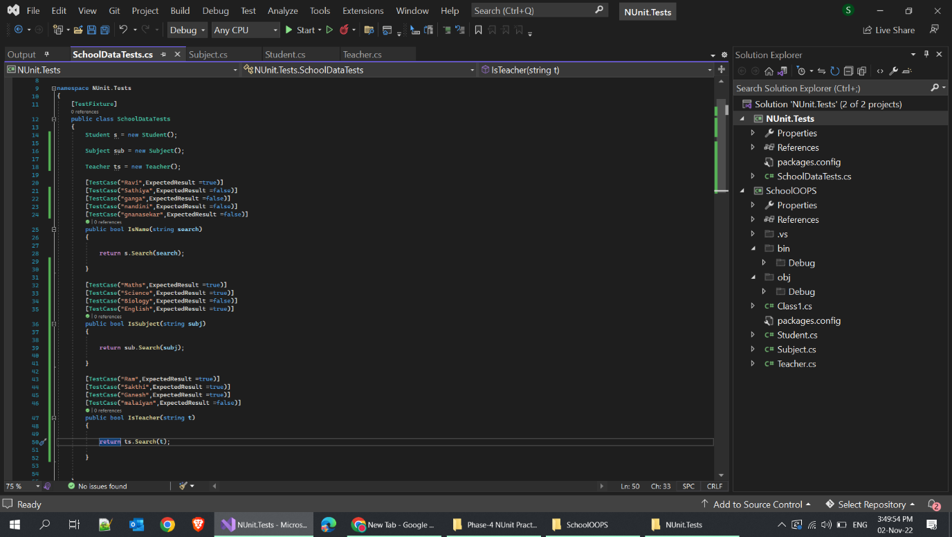

* 3 Test functions for student, subject and teacher classes with different testcases

**TESTRESULTS:**



